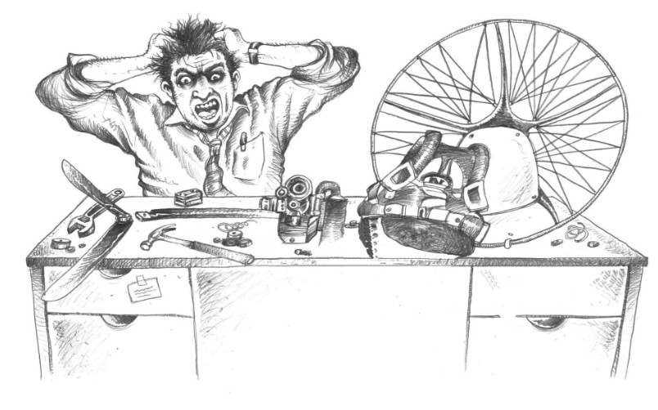

High, medium and low hook-in points on a paramotor
Technical note for instructors and pilots · Version 1.0 · 30 October 2026
Paramotor SA (Pty) Ltd t/a Apex Adventures · SACAA DTO 0012

Technical notes · General

Scope. What the hook-in point (hang point) is, how high, medium and low hook-in machines differ in flight, on launch and in landing, what weight shift adds, and what to check when a pilot changes from one type to another. It is built mainly on Jeff Goin's "Paramotor Harness: High/Low Hook-in, Weight Shift?" (PPG Bible, Section II, Chapter 12, footflyer.com), supplied as the Apex reference copy. All credit for the analysis and the photographs goes to Jeff Goin. Sizing figures from APCO and Dudek are added where they exist. The photographs are small web images from the 2007 article.

1. What is a hook-in point?
The hook-in point (also called the hang point or attachment point) is where the wing's risers connect to the harness or frame, usually through a pair of carabiners. How high it sits above the seat is the hook-in height. Machines are grouped as high, medium and low by that height and by what the attachment does.
Two ideas explain most of the differences:
- Pivot point. The place where the wing, risers and carabiners pivot on the harness or frame. It is often the bottom of the carabiner. If the carabiner is on a short piece of webbing that moves on the frame, that point of movement is the pivot. Whether the propeller thrust pushes above, on or below the pivot changes how the machine behaves.
- Centre of gravity (CG). The point where pilot and motor together balance, up and down and front to back. It sits inside the pilot, near the back. It is the sum of the engine, frame, fuel and the pilot. Pilots want the CG high and close to the back. The height is mostly a matter of adjustment. The distance behind the frame is a design feature of the motor.
What matters is the CG compared with the pivot point. If the CG is well below the pivot, the machine resists changes in tilt. If the CG is on or near the pivot, the pilot tends to wobble in pitch (fore and aft) and in roll. A machine with a very low pivot wobbles more, because its CG is barely below the pivot. And the farther the thrust line is from the pivot, the more a change in thrust moves the machine.
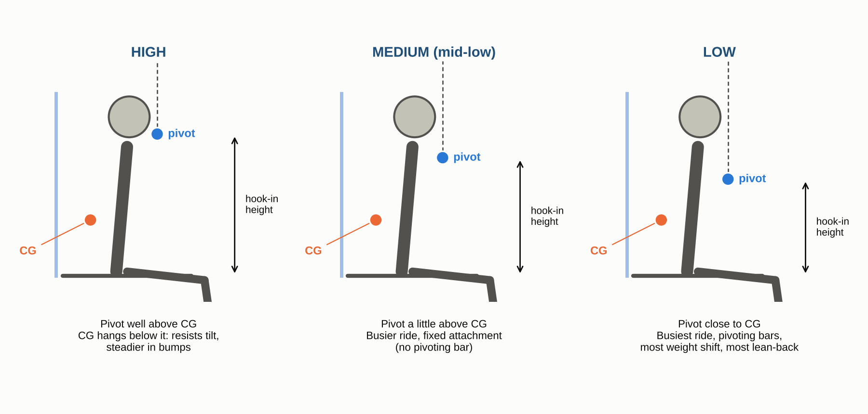
Schematic only, not to scale. Hook-in height rises from low to high while the CG stays about the same. Apex drawing from the PPG Bible description.

2. The three types
Goin analyses high, low without weight shift and low with weight shift. In this note the middle group is called medium (mid-low). There is also a hybrid, the Mantis, which is high on launch and landing and low in flight.
 | High | Medium (mid-low, no weight shift) | Low (with weight shift)
Attachment | Overhead or high on the harness. Often J-bars or a soft mount | Slightly higher than the weight shift type. No pivoting bars | Lowest points. Pivoting bars
Pivot against CG | CG well below the pivot | CG still close to the pivot, but the pivot is higher | CG very near the pivot
Ride in bumps | Steadiest. The motor moves less in turbulence | Busier than high, calmer than low | "Loose". Wobbles left/right and fore/aft
Weight shift | Little to none on most designs | None. Traded for a calmer ride | Most. Intended to copy free flight
Hands and brakes | Highest hand position | Lower than high | Lowest hand position
Lean-back and torque | Hang angle can be set fully vertical. Full power tends to angle the pilot back | In between | Leans back the most. More torque unless the machine is well adjusted
Learning | Slight edge for new pilots (several instructors) | Between | Can be distracting at first for new or transitioning pilots
Examples named by Goin | SD (J-bars), Fresh Breeze, Blackhawk, Fly Products | Bailey 4-stroke, Walkerjet | Airfer, PAP, Free Spirit, Fly Products (one model), Parajet

One maker's numbers. The APCO Split Legs harness is made in two versions. Seat to hook-in height is 420 to 480 mm (low) against 600 to 710 mm (high), depending on size. That is roughly 15 to 25 cm of difference between the two ends of the range. Dudek's Groundmaster ground-handling harness has adjustable hang points, so a student can copy the hook-in height of the machine they will fly. It is not for flying.
Most pilots stay with what they learned on. Goin finds that debates are almost religious, that marketing hype is "almost always just that", and that of those who switch, as many go from high to low as the other way. A properly adjusted machine of either type launches with nearly the same ease.

3. High hook-in
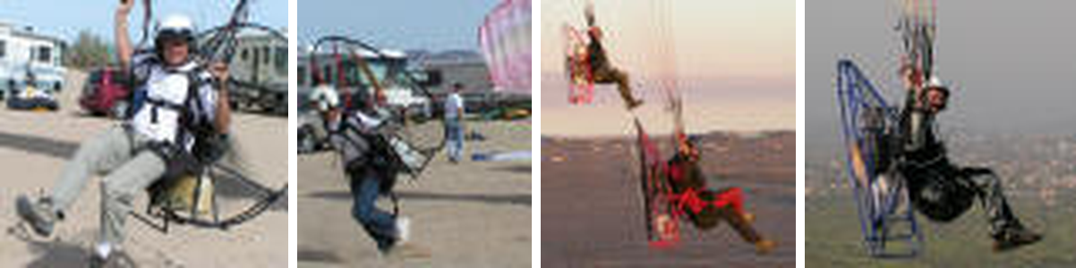
High hook-in machines (left to right, after Goin): pivoting J-bars on the SD, launching the SD, Fresh Breeze and Blackhawk with the harness attachment above, Fly Products with sliding webbing on a harness attachment system. Photos: Jeff Goin, PPG Bible.
The first paramotors used overhead J-bars and high hook-in points to balance the heavy motors of the day. Engines and frames are lighter now, but nearly all high machines still share the same geometry.
How it behaves
- The CG is well below the hang point, so the motor has less tendency to move in turbulence. Full power angles the pilot back and does not tip him forward.
- Hang angle can be set completely vertical, so the propeller plane is straight up and down. This is less comfortable in flight but generally easier to launch and it reduces torque effects.
- On soft mount systems the carabiners attach to harness webbing. The tilt-back can be set anywhere from vertical to far back, "even to a dangerous degree".
- Several experienced instructors who taught on both types found that high hook-in machines have a slight edge for new pilots.
What can go wrong
- Brakes out of reach. If the seat-to-carabiner height is too great, the brakes of a wing with long risers (some soaring wings) may be impossible to reach. Pilots have launched a soaring paraglider on a high machine without checking, and then could not reach the brakes. Check this before flying.
- Risers left too high. Goin shows an early weight shift system whose comfort bars floated up and let the pilot sink into the seat. The same motor later had a geared weight shift that held the bars lower and brought the risers down by about 4 inches. Do not condemn a system unless you have flown both.

4. Medium hook-in (low, without weight shift)
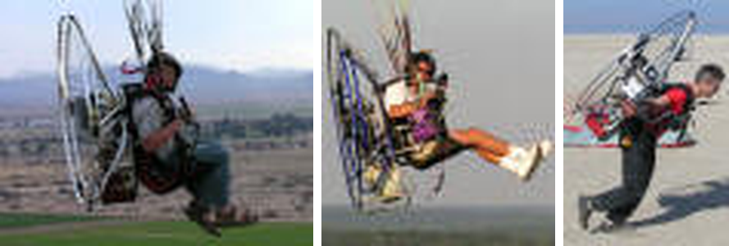
Medium (mid-low) machines, left to right: Bailey 4-stroke, Walkerjet, and inflation tests using the Bailey. Photos: Jeff Goin, PPG Bible.
These machines have attachment points slightly higher than the weight shift type and no pivoting bars. They could have points as low as the weight shift machines, but usually do not, because the aim is to reduce the turbulence passed to the pilot.
- The pilot gives up weight shift in return for a less wobbly ride in bumps.
- The CG is still close to the pivot, so there is much more wing movement passed on than with a high machine. The ride is busier than high, calmer than low with weight shift. Not having a pivoting bar calms it further.
- Launch and landing technique is unchanged. Hand position is a little lower than on a high machine.

5. Low hook-in (with weight shift)
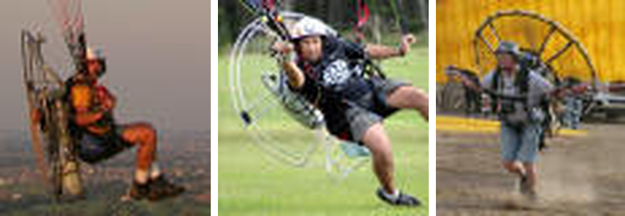
Low hook-in machines with weight shift, left to right: Airfer, PAP (photo by Jamie Beckett), Free Spirit being launched by Robert Kitilla. Photos: Jeff Goin, PPG Bible.
Most low machines are of this type. They have the lowest points and pivoting bars to increase weight shift. The aim is to copy free flight as closely as a motor allows. Free fliers like the feedback when looking for thermals, and soaring pilots can fly their soaring wing with similar brake positions. Many motor pilots prefer less of it.
Features of all low hook-in machines
- Low risers must connect closer to the arms. Moving to a more forward point risks leaning back too far. Too much lean-back can twist the risers on launch or in flight.
- The pivot is near the CG, so the ride is busier. Bumps pass more movement through the wing.
- With weight shift the machine feels very "loose". It takes several flights to get used to, and a new or transitioning pilot finds it distracting at first.
- These machines lean back the most. Even with the risers on the most aft setting there is a fair amount of lean-back at Goin's weight. That means more torque, which can be reduced to an acceptable level on a well designed and properly adjusted machine.
- APCO says its split-leg seating "holds much greater potential for improved weight shift" and is "great for slalom flying", and that dropping the hard seat plate makes it easier to put the power unit closer to the body. These are the maker's claims.
Brake and cage hazard at full power. On low machines, full power before the pilot is seated tends to tip the top of the cage forward. This can put the brake handles very close to the cage, and a brake let go of can then go into the propeller. Goin knows of about five cases. In each the brake was cut off before it wound up, which was luck. Keep the brakes under control through the whole launch, and check the cage clearance in the checks below.

6. Launch, landing and hand position
- Launch. There is "precious little" difference in technique or difficulty between high and low machines. Only the hand position differs, and it is lower on low machines. Be ready to hold the brakes lower while damping the inflation.
- Learning. New pilots seem to learn slightly more easily on high machines. The Mantis hybrid was designed for exactly that: high for launch and landing, low in flight.
- Cage and D lines. If the cage pushes out on the D lines during inflation, the wing struggles to come up. A way round it is to start the inflation leaning well forward so the cage is above the lines, then get the lines up past the cage quickly. Lines catching on anything on the cage will ruin the launch.
- Brake position. You can make the brake position on a high machine match a low one by letting the brakes out a little longer.
Motor risers on a low machine. Wings made for motoring often come with shorter risers to suit high machines. On a low hook-in machine the brakes can end up much lower than expected. The main risk is that the wing overflies you and you use too little brake to damp it. You may also need more brake, or wraps, to flare. Do not mix risers and hook-in type without checking.

7. Adjustment decides everything
Goin repeats that adjustment is critical on every harness system, high or low. He has flown machines of both types that were nearly unairworthy until changed.
His example: a borrowed motor of a familiar brand could barely be launched, because the torque turn was so bad as the wing lifted. The harness was attached on the wrong side of the engine, which let the motor move toward the right shoulder and caused a severe torque twist. Moving the harness and frame attachments to the other side of the motor cured it completely.

8. Checks when a pilot changes type
Derived from the cautions above. Run them with the instructor, before the first flight on a new machine.
- Know the type. High, medium or low, with or without pivoting bars, and the make and model.
- Risers against hook-in. Are the risers the right length for that hook-in height? Motor risers on a low machine, soaring risers on a high one.
- Brake reach. Sitting in the harness, reach and hold both brakes with the wing's risers. On a high machine with long risers, check you can reach the brakes at all.
- Hang angle and lean-back. Set the hang angle and riser position as the manufacturer allows. Check the tilt-back in a hang test, and do not exceed what is safe. Check for riser twist with the pilot leaning back at full power.
- Cage clearance. With full power on and the pilot not yet seated, check where the top of the cage goes. Brake handles must not be able to reach the propeller.
- Cage and D lines. Check that the cage does not push out on the D lines, and that the lines catch on nothing.
- Harness and frame attachment. Correct side of the engine, and no twist or off-centre pull toward one shoulder.
- Ground practice first. Inflation and kiting on the new machine, then a short, low-risk first flight with the instructor watching.
- Record it (section 9) and let the CFI sign.

9. Hook-in change record
Date | Pilot | Old and new machine (type) | Risers and brake reach | Hang angle, cage clearance | Instructor | CFI check

10. Sources and cautions
- Paramotor Harness: High/Low Hook-in, Weight Shift? (Jeff Goin, PPG Bible, Section II Chapter 12, 15 Jan 2007, footflyer.com). The main reference. Text, classification, examples and photographs. Related chapters named by Goin: Hang Angle Adjustments, Suspension Systems, Harness Myths, Understanding Paramotor Torque, Understanding Harness Terminology.
- Split Legs Paramotor Harness, LOW and HIGH (APCO Aviation, apcoaviation.com). Seat to hook-in heights of 420 to 480 mm (low) and 600 to 710 mm (high).
- Groundmaster training harness (Dudek Paragliders, dudek.eu). Hang points are adjustable so the harness can copy your usual setup. Ground handling and training only, not for flying.
- ASC low-hangpoint system (Fly Products, reported by XC Mag, 2016). The maker claims "greatly reduced propeller torque effect". Not independently tested.

